A000-US-TN-White Pine-Plummet-Andesite-1000 CE

**Case no.:**

**Accession Number:**

**Formal Label:**

**Display Description:**

**LC Classification:**

**Date or Time Horizon:**

**Geographical Area:**

**Map:**

**GPS coordinates:**

**Cultural Affiliation:**

**Media:**

**Dimensions:**

**Weight:**

**Condition:**

**Provenance:**

**Discussion:**

**As Moorehad wrote (1910 1:**

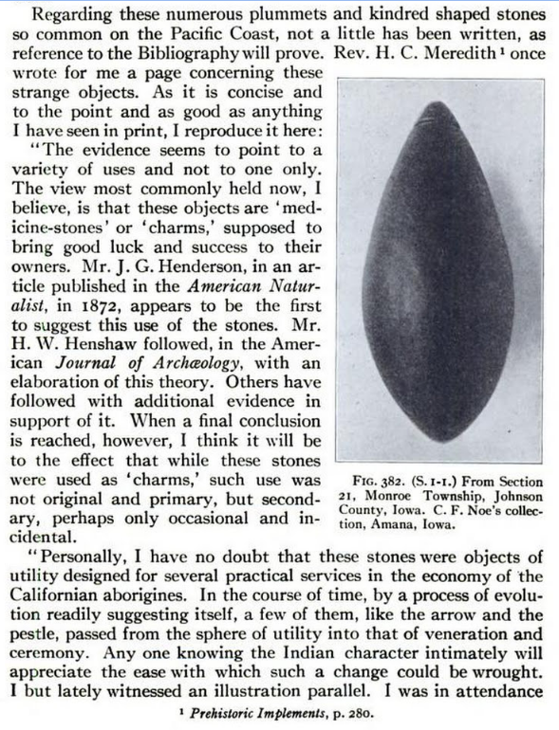

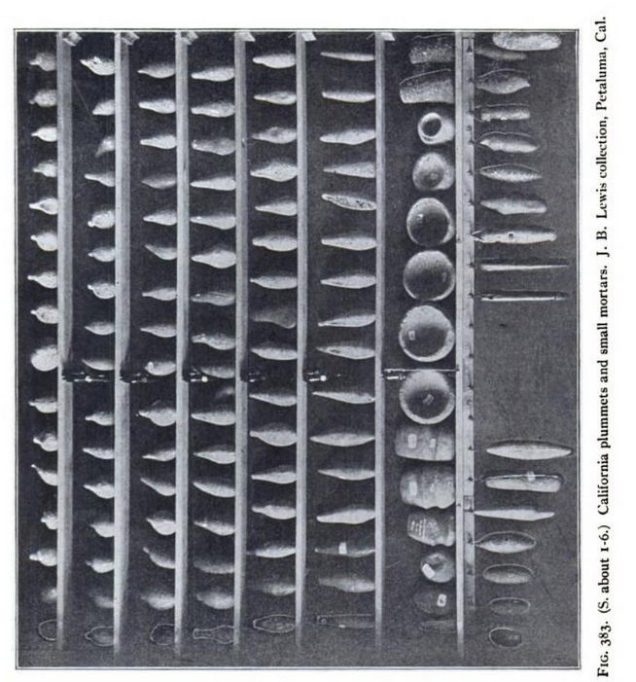

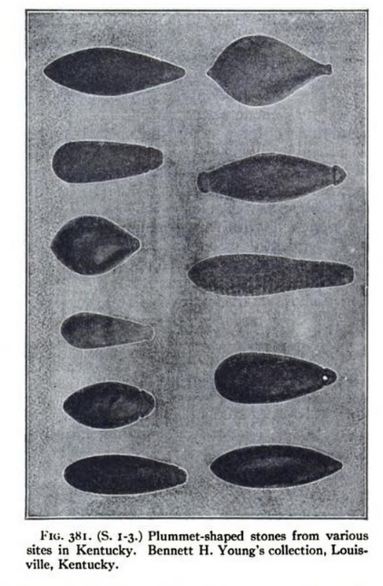

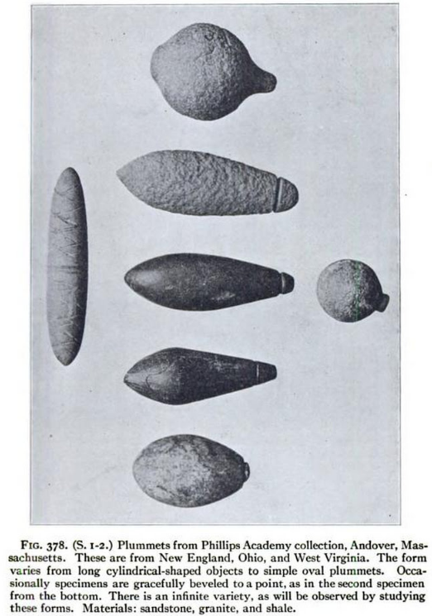

**References:**

Moorehead, Warren King. 1910, The stone age in North America; an archæological encyclopedia of the implements, ornaments, weapons, utensils, etc., of the prehistoric tribes of North America, with more than three hundred full-page plates and four hundred figures illustrating over four thousand different objects, by Warren K. Moorehead ...Boston, New York, Houghton Mifflin Company